Uploading your imaging
Step 1
Insert the CD into your computer. Many CDs will launch automatically if it does please close the application.
Step 2
Open My Computer
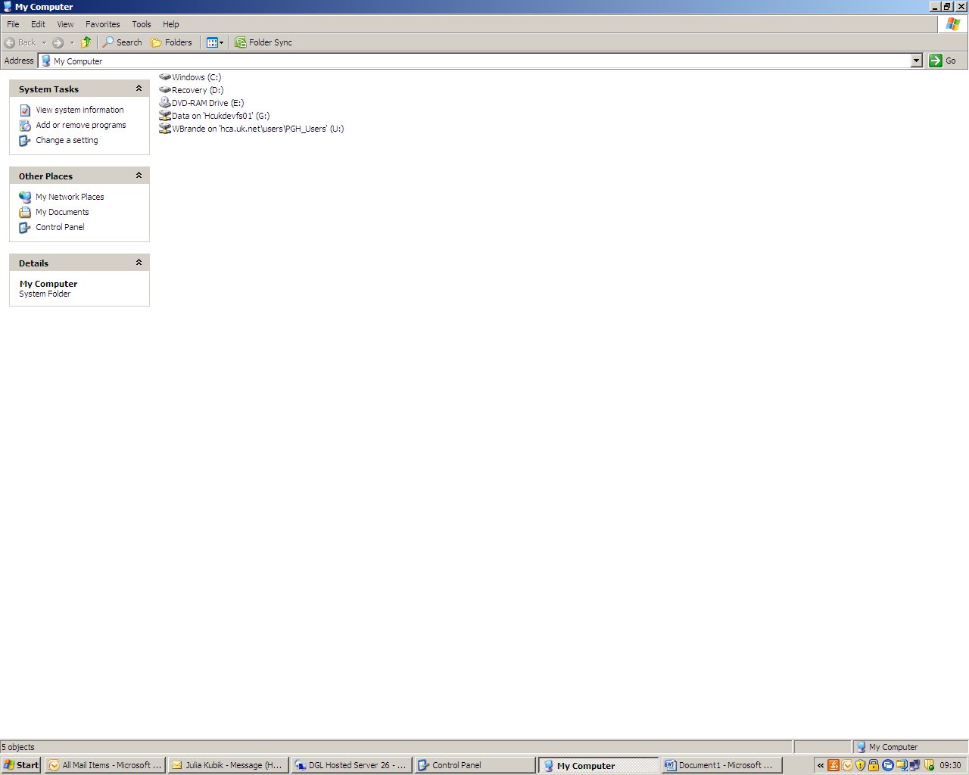
Step 3
Right click on the CD and choose ‘explore’
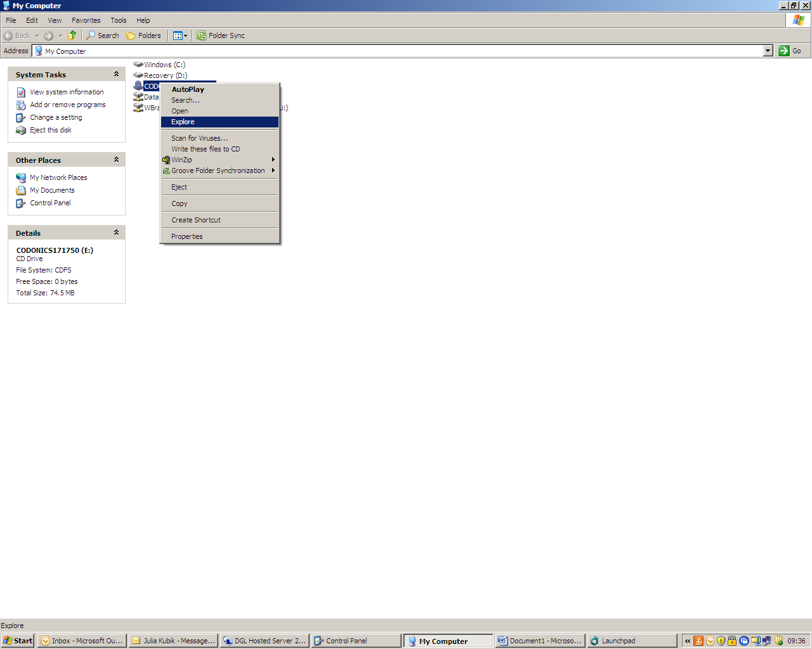

Step 4
Select all the files in the window
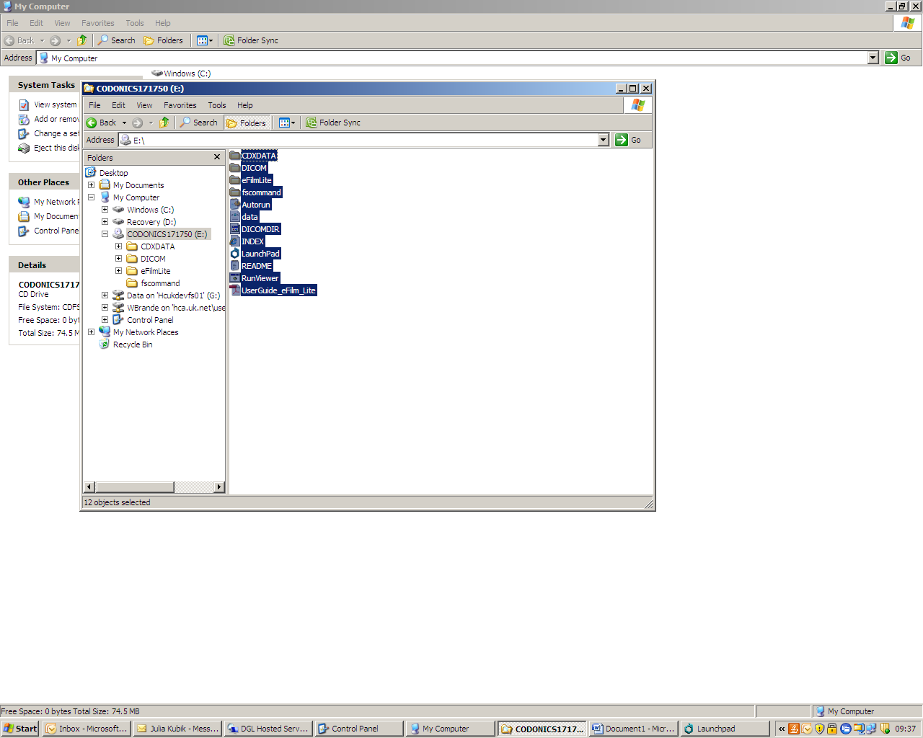

Step 5
Right click on the blue highlighted files and select winzip then add to zip file. If you do not have winzip there is a link available for you to install it.
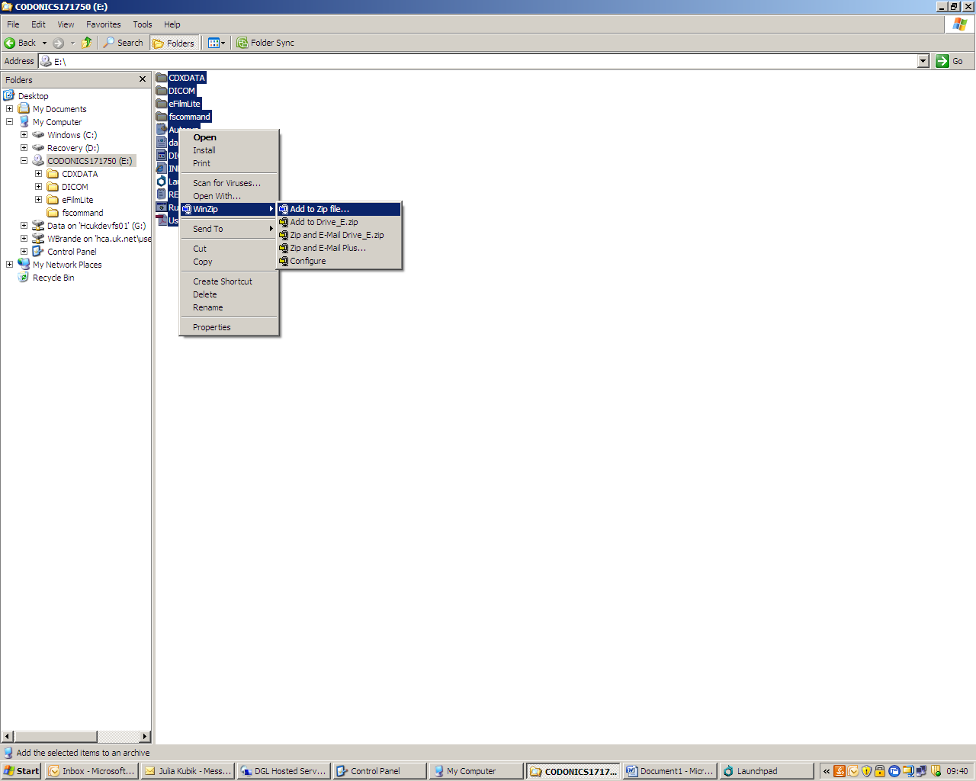
Step 6
Save this file on the desktop of your computer – use your name and date of birth as the file name.
Step 7
Open internet explorer and go to https://airdropper.com/mast
You will be asked for a pass phrase which is MAST1
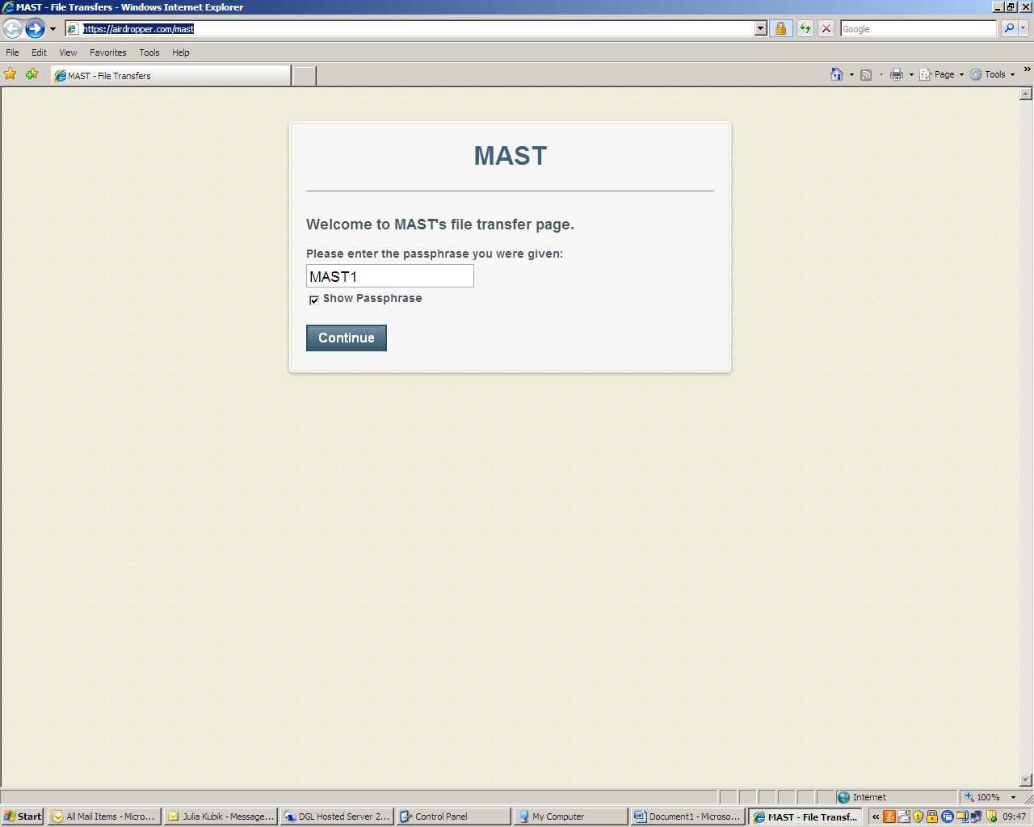
After entering the phrase click continue
Step 8
Click add files, choose the file that you have just saved and press open your screen should look like this.
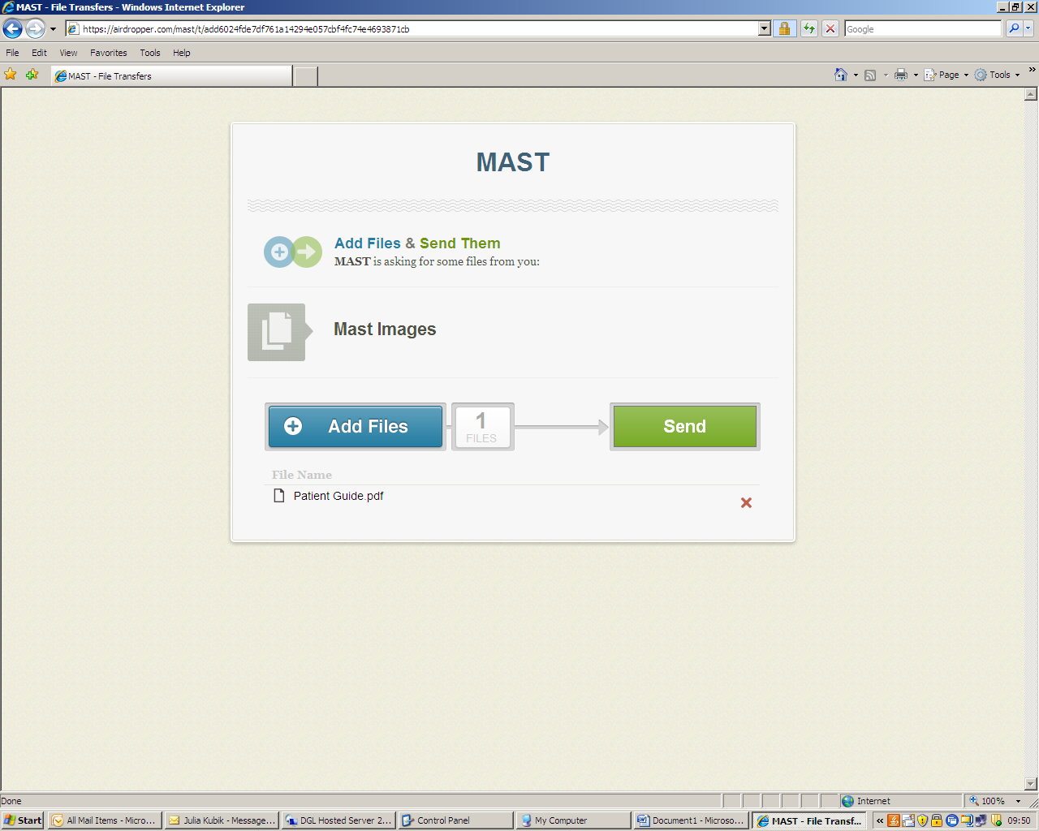

Step 9
Press send – your screen should look like this

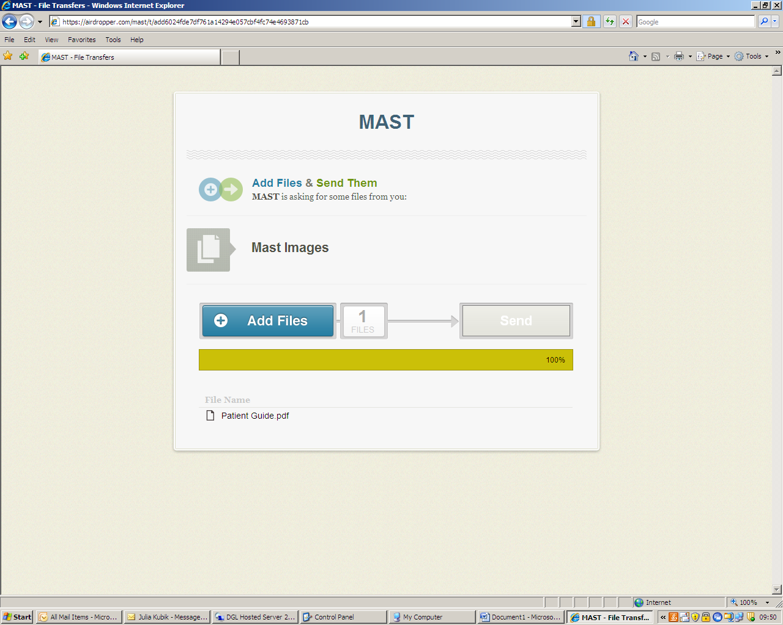

Once the upload is completed the screen will look like this
